ASE LAB ASSIGNMENT 9

Lab ID: 6_2

Name: Udaya Byreddy

Student ID: 16293204

Class ID: 3

Partner Name: Madhuri Sarda

Student ID: 1691679

Class ID: 21

**Login Page (index.pug) code:** Login page is created using PUG template engine.

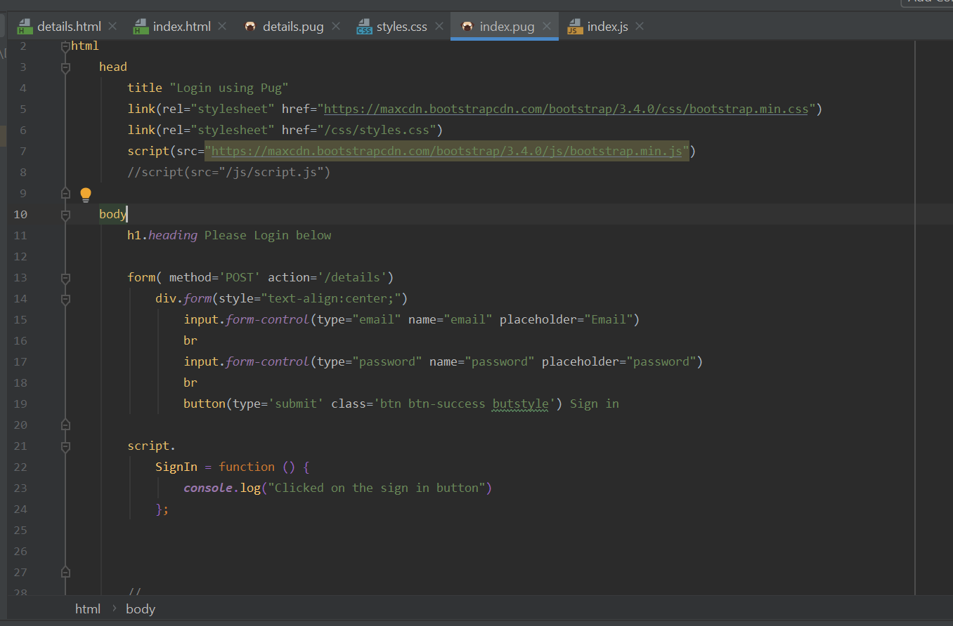

**All css classes are written inside public/css/styles.css file.**

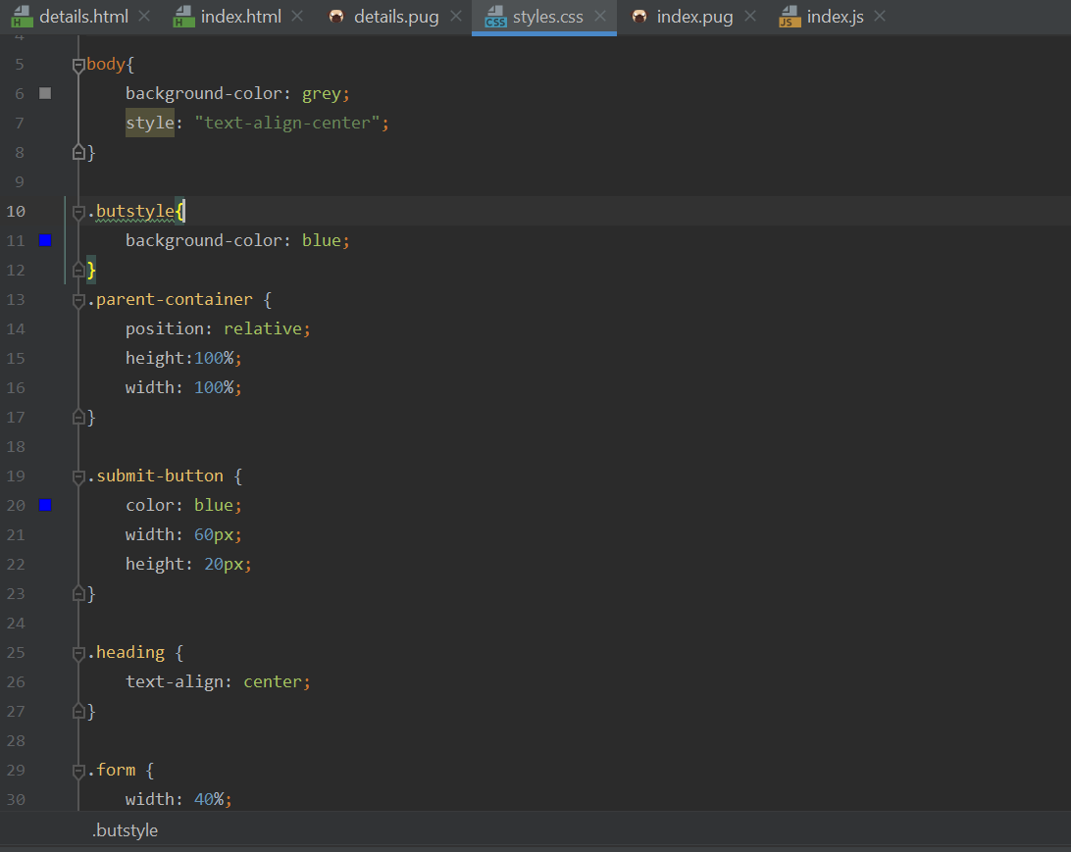

Details page code which is created using PUG template engine.

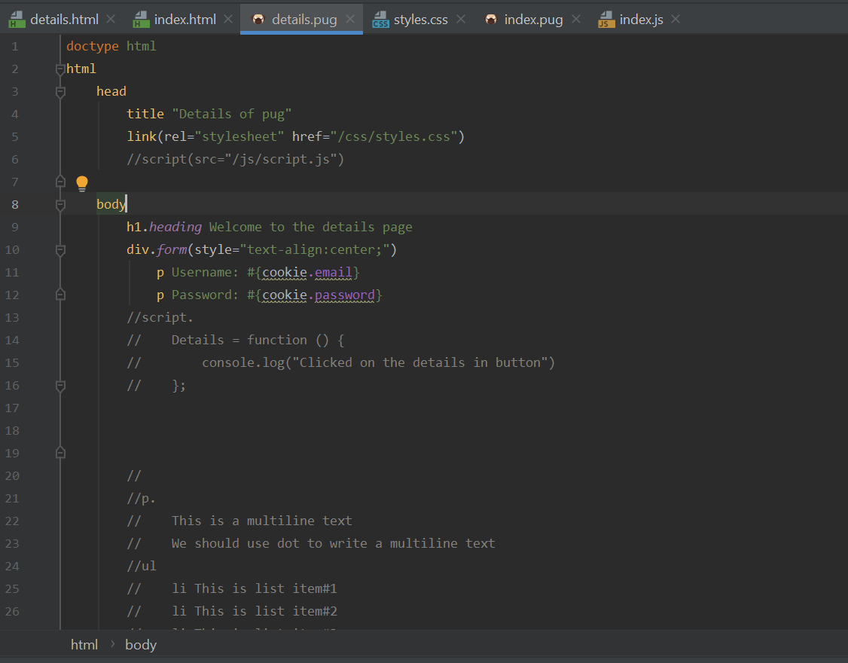

Index.js code page

index.pug file will be rendered as the default html page. This file also contains post methods to store user's details and address in cookies.

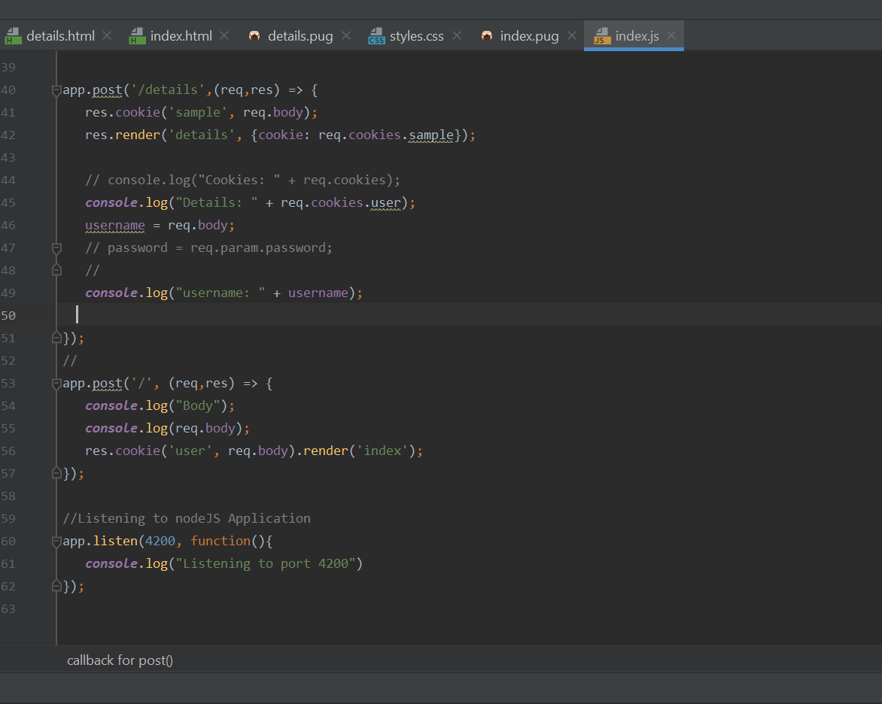

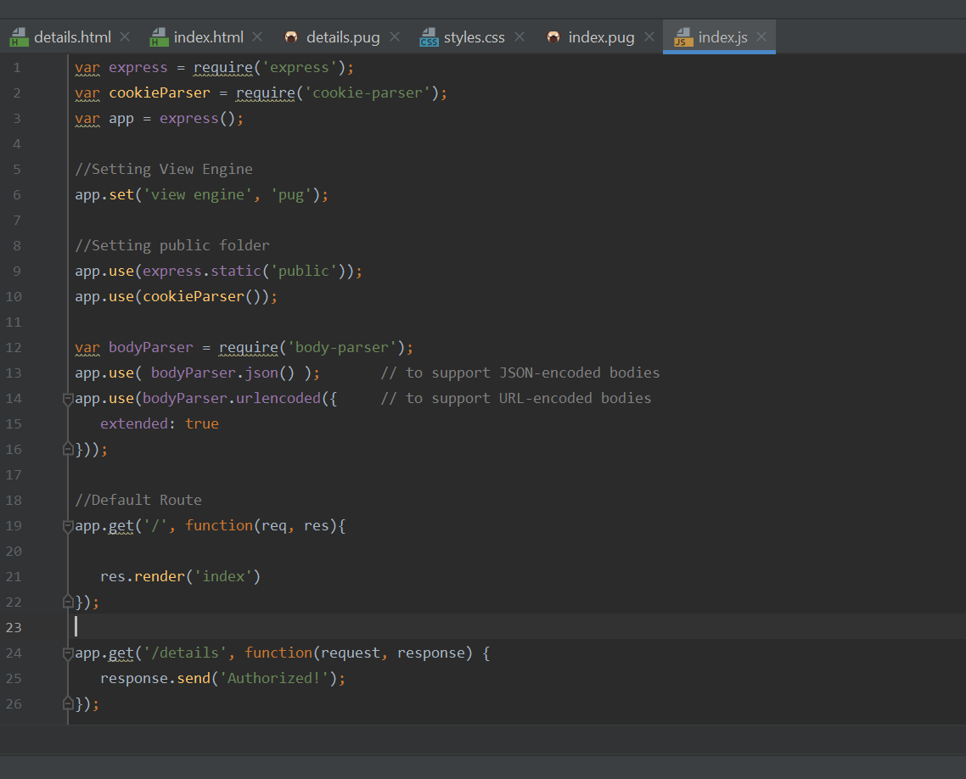

LOGIN PAGE using PUG Template engine

